SIGNING OF 2024 PERFORMANCE CONTRACTS FOR MUNICIPAL AND DISRICT ASSEMBLIES IN THE AHAFO REGON
In line with its mandate, the Ahafo Regional Co-ordinating Council organized the ceremony for the signing of the 2024 Performance Contracts between the Municipal/District Chief Executives and Municipal/District Coordinating Directors in the Region. The event was witnessed by the Hon. Regional Minister, George Boakye and Chief Director, Sampson Amoako Kwarteng. The occasion was also used to sign the Performance Contract between the Chief Director and the Regional Minister.
The ceremony took place at the Conference Room of the Ahafo RCC on Friday, 23rd February, 2024 and was graced by some Heads of Department and staff of the Regional Co-ordinating Council.
The ceremony for the signing of the contracts was part of the processes leading to the implementation of the Performance Management System (PMS) of the Local Government Service for the year 2024.
.
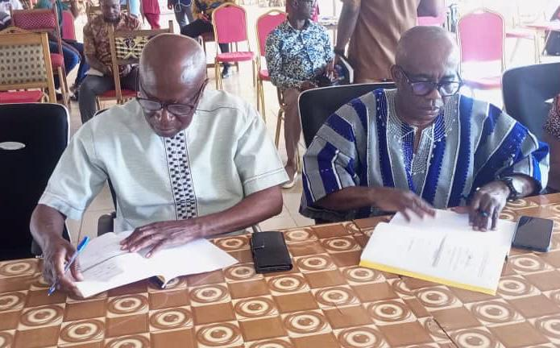
Hon. Regional Minister and Chief Director witnessing the PC signing ceremony
In a brief remark to the Hon. M/DCEs and the M/DCDs, the Hon Regional Minister thanked all of them for committing to this all-important component of our local government administration framework.
He encouraged Hon. MDCEs to endeavour to provide the needed resources to execute the deliverables. He also urged the MDCDs to rally rest of the staff round to ensure the effective and efficient service delivery.
Responding to the Regional Minister’s call, the dean of Hon. MDCEs, Hon. Yaw Osei-Boahen, the MCE for Asunafo North assured the Hon. Regional Minister of their determination to achieve the set targets in order to push the Region to greater laurels.

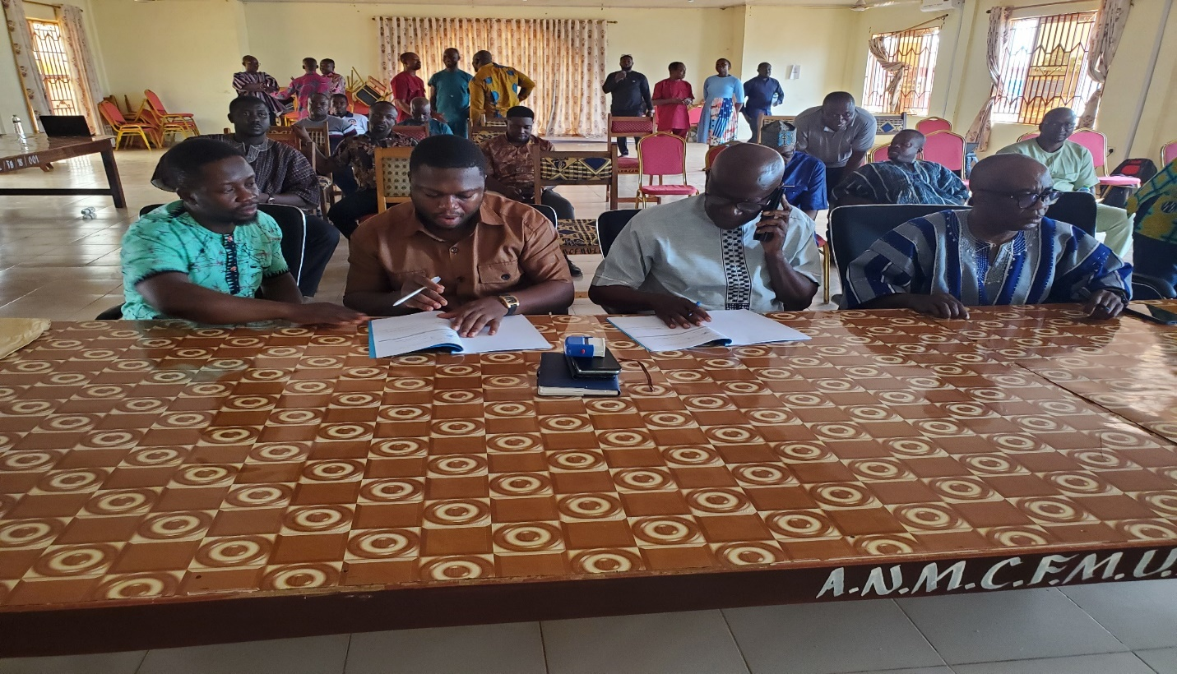

ASUNAFO SOUTH DISTRICT ASSEMBLY
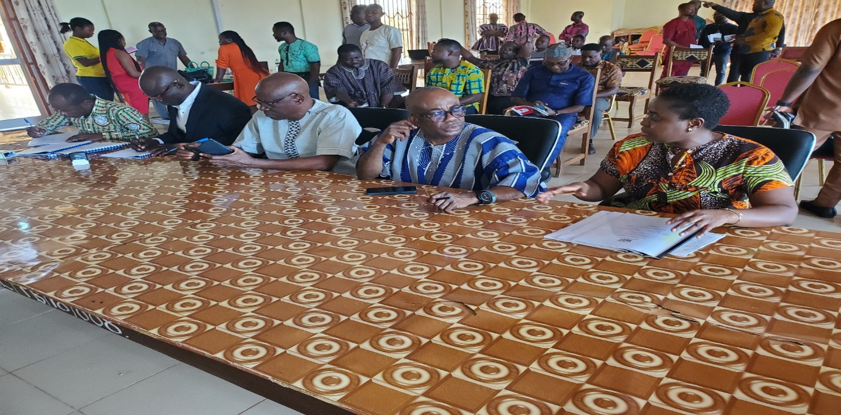

ASUTIFI SOUTH DISTRICT ASSEMBLY
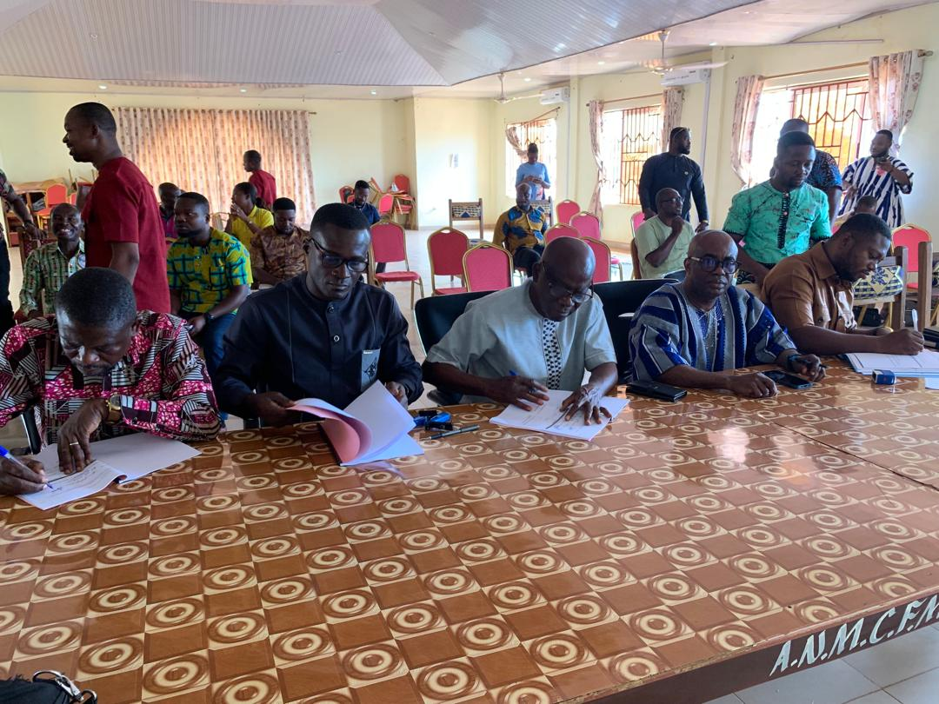
TANO SOUTH MUNICIPAL ASSEMBLY

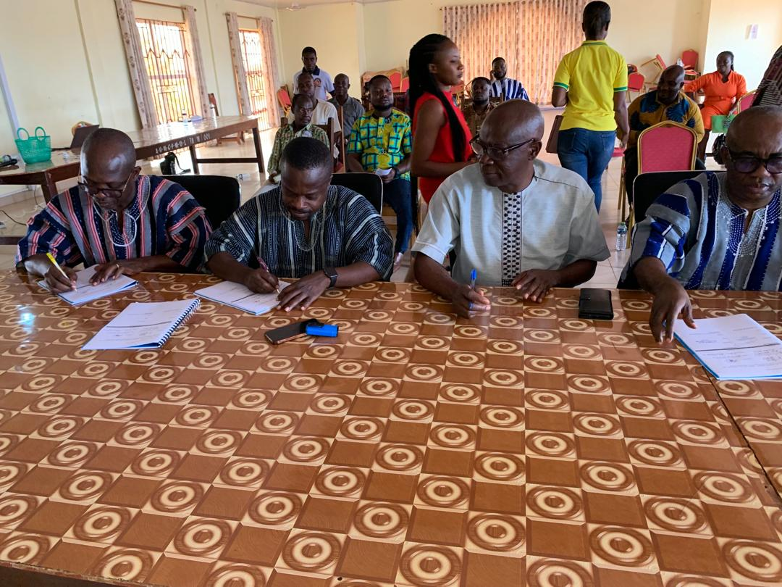
TANO NORTH MUNICIPAL ASSEMBLY

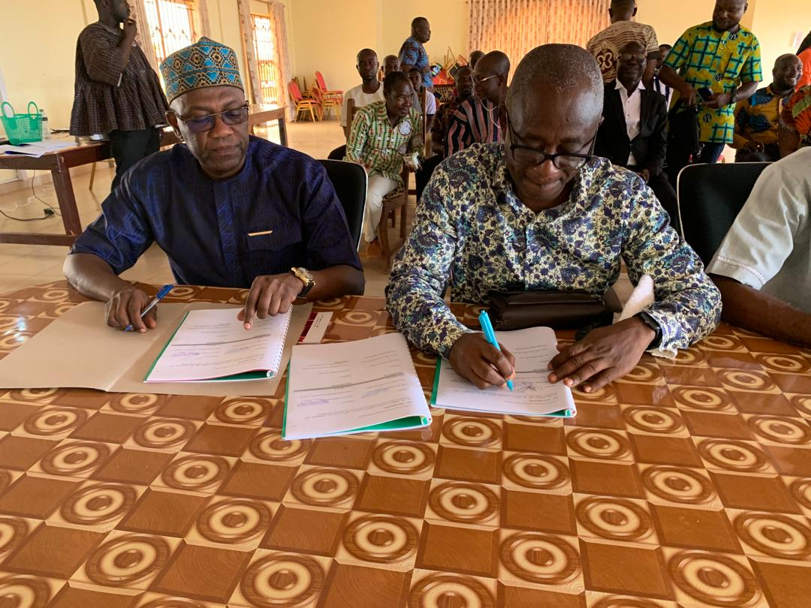
ASUNAFO NORTH MUNICIPAL ASSEMBLY
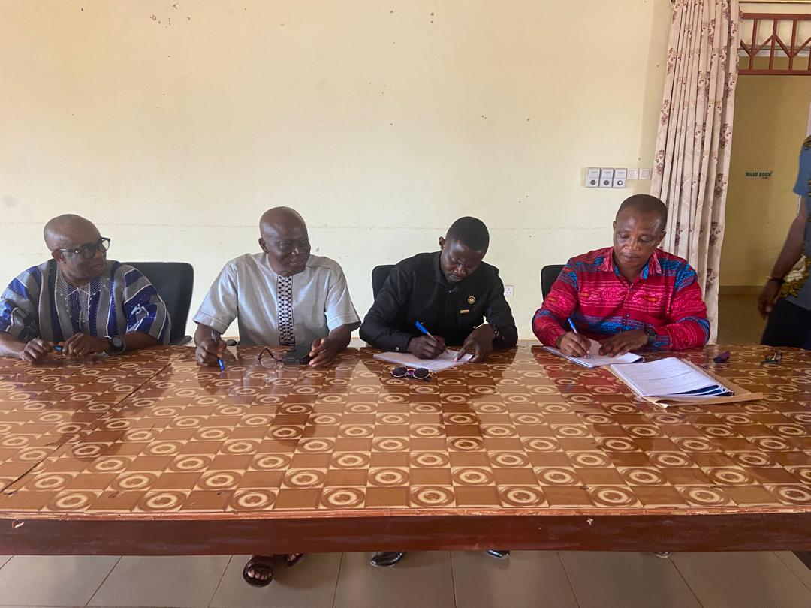
ASUTIFI NORTH DISTRICT ASSEMBLY

