- INTRODUCTION
The Ahafo Regional Coordinating Council in collaboration with Netcentric Campaigns is building a Network of people to address challenges around inadequate water, sanitation and hygiene services in Ahafo region. The core aim is to connect residents, various organizations and local government personnel to create a robust WASH Network to alleviate Water, Sanitation and Hygiene challenges. The approach involves a network of key people and popular citizen support dedicated to championing wash literacy, public engagement and recruitment of community members who can drive WASH initiative to success.
In line with this, a 4-day training workshop was organized for participating districts on setting up a WASHDESK which will serve as the catalyst and hub for all activities that generate the engagement necessary to build this vital WASH Network.
This report provides a detailed account of what transpired at the training workshop and seeks to inform relevant stakeholders accordingly.
A total of 63 participants undertook the training. 14 of them representing 22.2% were females with 49 of them representing 77.8% being males. Among the dignitaries present was the Chief Director of Ahafo Regional Coordinating Council who in his opening address noted the need to establish District WASHDESKs which will serve as a gateway for building robust WASH network and delivering WASH Customer services in line with the ongoing District based full WASH coverage initiative under the Ahafo Integrated WASH Programme. (See appendix I, address by Chief Director).
2.0 ACTIVITIES
DAY 1
ROLE OF PUBLIC IN WASH SYSTEMS
According to Netcentric Campaigns in a brief presentation, users of WASH systems are critical to sustainable WASH Services. Giving further details on the role of public, the following were stated:
- The involvement of people will give them opportunity to bring out or report problems in the WASH System.
- They will help detect illegal payments within the WASH System.
- The people provide feedback on the changes in water system or water quality.
- They amplify the value produced by the WASH System (i.e., health & hygiene).
However, there should be a mechanism to continuously engage the public as problems within the WASH System has to be solved by regular communication and community engagement.
SELLING THE NETWORK TO PEOPLE
On selling or marketing the network for people to join, Facilitators indicated that people will join the network if the network provide value for them. Facilitators therefore urged participants to consider value in selling the network to people.
It was also noted that participating districts should build the network in the context of existing WASH Master Plans.
In addition, participants were divided into groups and were asked to sell the network to identified groups (e.g., Farmers, taxi drivers etc).
Picture1: Group Sharing on how to sell the network to public
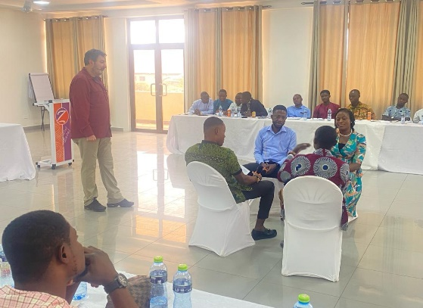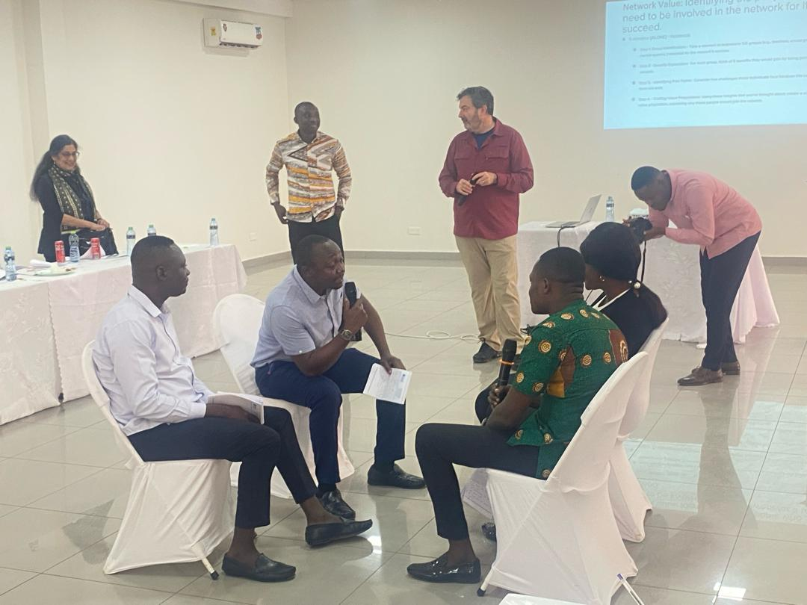

GOOD CUSTOMER SERVICE
Facilitators introduced participants to what is considered as good customer service. Participants were then grouped to suggest ways to enhance good customer service. Among the comments made by groups on this course include:
- Consider culturally sensitive approaches in dealing with customers
- There should be a feedback mechanism where information on issues addressed get back to customers
- Demonstrate strong commitment towards working with customers.
- Address the issue of inadequate logistics for officers to meet customer satisfaction
DAY2.
PRESENTATION ON WASHDESK
Facilitators emphasized on the importance of WASHDESK in building a robust Network. They stated that Districts are going to use their own staff as WASHDESK officers. The WASHDESK receives, document and track WASH issues and make sure people have the needed information. The WASHDESK will also engage people and address their concerns. In general, District WASHDESKs will focus on the following core functions:
- Listening, tracking, understanding and responding to community concerns and stories about WASH in the district
- Consistent, thoughtful outreach and engagement across the district to protect, expand and leverage WASH improvement through necessary campaigns
- Organizing and convening an inclusive adversary group of key players monthly to collaborate on advancing WASH literacy, identify issues and drive solutions.
The overall effect of doing these functions is to get the right people engaged in transforming WASH in each District, facilitators emphasized.
On client service roles and its challenges, participants were divided into groups and were asked to state challenges that could affect good service delivery. Among the challenges mentioned was inadequate logistics in their line of work and lack of capacity building training. They recommended the provision of adequate logistics and capacity building training to help improve service delivery.
Picture 2: Client Services and Challenges
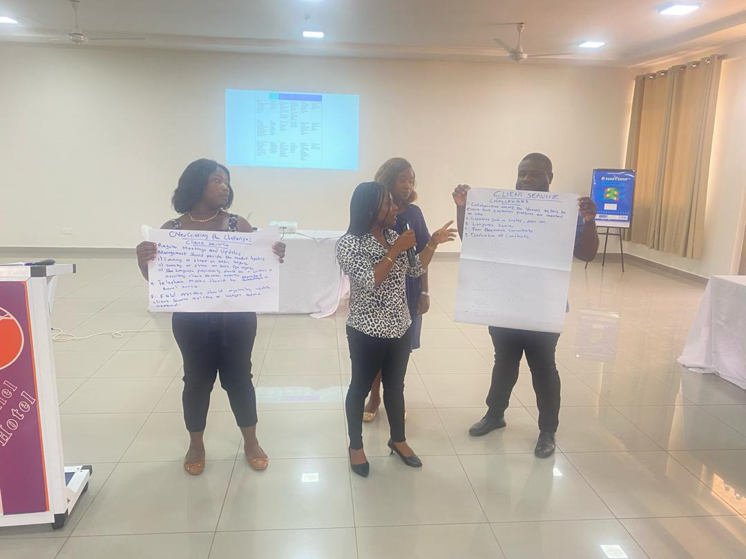

Facilitators also introduced participants to WASHDESK website and mNotify platform for enhanced WASH Customer service and engagement. They noted that, once the District WASHDESK is established, IT Officers will oversee its operation and utilization to enhance WASH customer service and engagement in the district. They will post WASH news and Campaigns on the website, monitor and maintain the mNotify platform and ensure data security and compliance.
DAY3
COMMUNICATIONS and CAMPAIGNING
Facilitators introduced participants to communications and campaigning which are vital for WASHDESK Network. The communication approaches mentioned include outreach and invitation into the network, maintaining interest and mobilizing people across the network to impact behaviors and attitudes. In particular, Miss Krishna Roy mentioned audience understanding, leveraging diverse communication channels and crafting targeted campaigns to help in this effect.
In addition, participants were grouped to review the calendar of events and opportunities to help conduct this work.
At the end, participants appreciated ways to achieve WASH objectives through strategic communication.

DAY 4
ADVISORY GROUP
Facilitators indicated that the district advisory group will discuss issues/complaints from the WASHDESK and prescribe best ways of addressing issues. They noted that those with expertise, influence and resources should be considered in forming the advisory group. Traditional leaders, CSOs and Women should have appointment in the advisory group. They added that the District WASH advisory group should maintain regular meetings to discuss issues coming through the WASHDESK.
3.0 CONCLUSION
Building a robust WASH Network is essential in addressing the pressing Water, Sanitation and Hygiene challenges within the Ahafo Region. Various WASH actors are therefore entreated to demonstrate strong commitment towards achieving WASH objectives spelled out in District WASH Masterplans.

APPENDIX I
ADDRESS BY CHIEF DIRECTOR, AHAFO REGIONAL COORDINATING COUNCIL

APPENDIX II
PICTURES FROM THE MEETING
